Introduction
This report presents a preliminary, exploratory analysis of the residence life survey dataset for the 2023 to 2024 academic year. The purpose of the analysis is to evaluate the structure, completeness, and overall quality of the data prior to conducting further statistical analysis or modeling. All data processing and analysis were performed using the R programming language.

Preliminary Dataset Summary
- Number of Rows: 318
- Number of Columns: 85
- Number of Numeric Columns: 1
- Number of Character Columns: 84
- Number of Factor Columns: 0
- Total Number of Missing Values: 32
- Total Number of Duplicate Records: 0

Columns with Missing Values
The missing responses are concentrated in several open-ended feedback questions, including additional comments on dining, residence life programs, campus safety and facilities, residential culture, experiences with resident assistants, and suggested campus programs. The number of missing responses in these fields ranges from 2 to 5 per column, which is expected because these questions were optional text responses.

Interpretation
The CSV file was successfully loaded into R as resident_life_table for a preliminary analysis. The dataset contains 318 rows and 85 columns, indicating a moderately large, survey-style dataset with numerous variables per respondent. An assessment of data completeness revealed 32 missing values across the entire dataset, and no duplicate records were identified. This relatively small number of missing entries suggests the data is largely complete, with missingness primarily occurring in optional qualitative feedback fields rather than in the key quantitative variables. Overall, the dataset appears suitable for further statistical analysis, though the identified missing values should be reviewed and handled appropriately during later stages of data preparation/modeling.

Appendix – R Code and Console Output
Data Import Code:
Number of Rows:
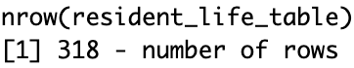
Number of Columns:
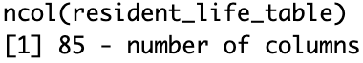
Number of Numeric Columns:
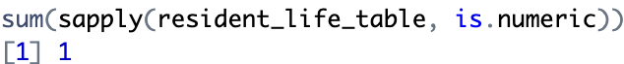
Number of Character Columns:
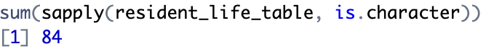
Number of Factor Columns:
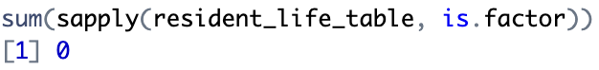
Total Number of Missing Values:
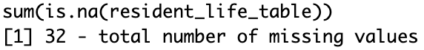
Columns with Missing Values:
